Software Project Lab-1

Project Proposal

**Supervised By:**

Rafid Mostafiz

Lecturer

Institute of Information Technology

Noakhali Science and Technology University

Email: [rafid.iit@nstu.edu.bd](mailto:rafid.iit@nstu.edu.bd)

**Presented By:**

Mission Devnath

Id: ASH2125002M

Year:2nd term:1st

Email: mission2516@student.nstu.edu.bd

# **IIT HELPDESK**

**Introduction**

The command line interface chatroom (Client-Server model) can be an excellent tool for communication and collaboration, especially for those who prefer to use the command line interface over graphical user interfaces. CLI chatrooms provide a simple and straightforward way to chat and exchange messages, without the need for a browser or any specialized software. The Client-server model is a distributed application structure that partitions task or workload between the providers of a resource or service, called servers, and service requesters called clients. In the client-server architecture, when the client computer sends a request for data to the server through the internet, the server accepts the requested process and delivers the data packets requested back to the client. Clients do not share any of their resources.

Additionally, CLI chatrooms can be easily integrated into scripts and automated processes, making them a popular choice for developers and system administrators. By using this cli chatroom students enrich their communication and supporting skills through it in online.

Overall, CLI chatrooms can be a useful tool for anyone looking for a quick and efficient way to communicate with others in a command line environment.

**Objectives**

By using this cli chatroom students can easily share their opinion and ask any questions from their teachers. Students can save their time through this software. Rather than office authority can send their any official notice in it.

**Target Customers**

* Students
* Teachers
* Office Authorities

**Application Features & Description**

* **End to End encryption:** For maintaining security issues we need to encrypt and decrypt messages.

* **Multi-client facilities:** Multiple clients easily communicate with each other.
* **Message history:** As every message is saved in file, so office authority can reply help related messages in their free time.

**Models, Tools, and Resources**

* **Agile**: Agile is a popular software development model that emphasizes iterative development, frequent feedback, and collaboration. CLI chatrooms can be used to facilitate communication between team members, keep track of progress, and make quick decisions.
* **Programming Language**:
* Java
* **IDEs:**
* IntelliJ Idea
* Eclipse
* **Resources:**
* Google

**Deliverables**

* Source Code
* Document
* Jar File

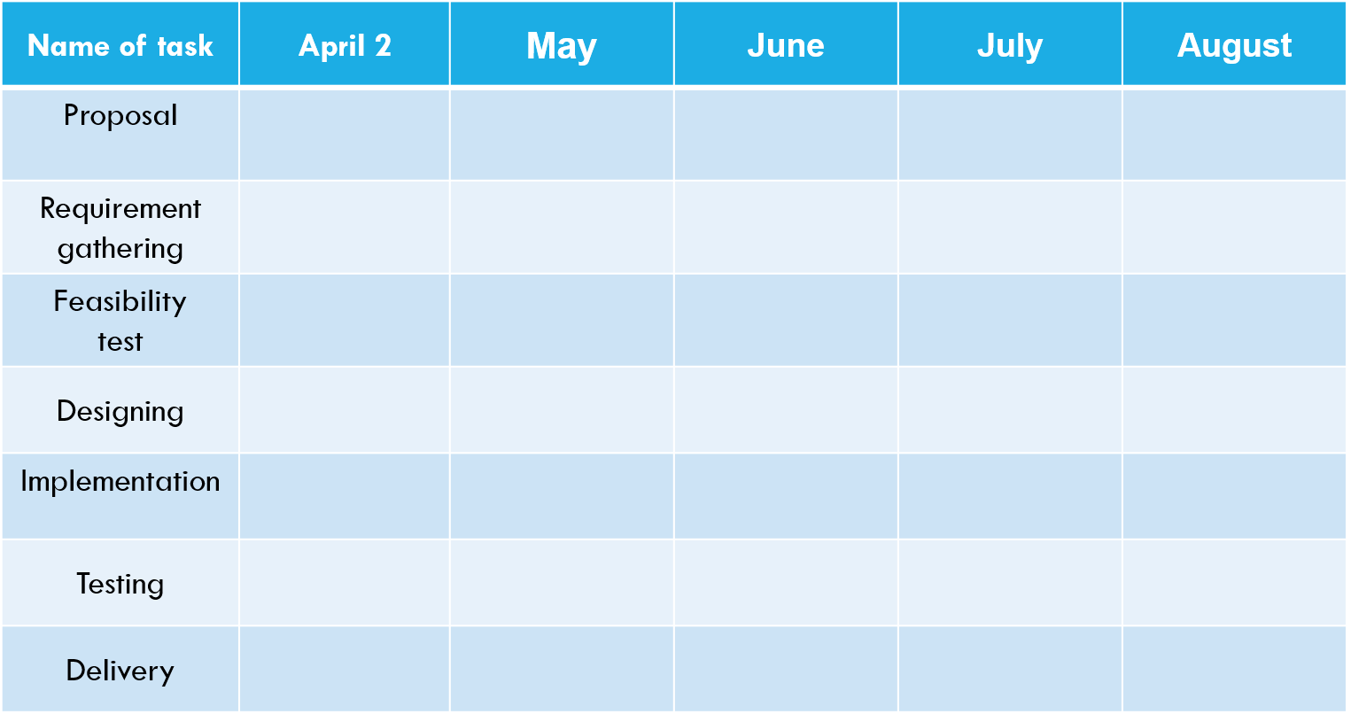**Proposed Timeline**

**Challenges**

* Manually creating a chatroom is a hectic process.
* Build this project on time.
* Ensure the quality of this project.
* Securing and saving data.
* Create the network environment through cli.
* Implementation.